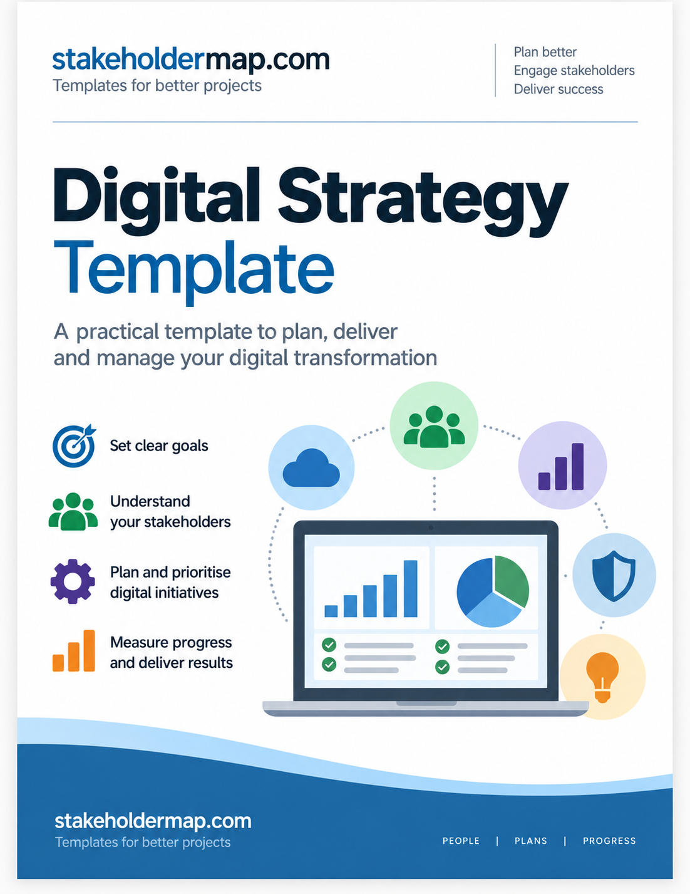

DIGITAL STRATEGY
TEMPLATE
A practical Word template for turning business goals into digital actions.
Organisation
Strategy owner
Version
Date
Review date
Approved by

stakeholdermap.com

How to use this template
Start with the business problem or opportunity. Then work through the sections in order. Keep the parts that help you and remove anything you do not need.
- Write for the people who will use and approve the strategy.
- Describe outcomes before choosing technology.
- Give each important goal a measure and target.
- Give each action one owner and one due date.
- Review the strategy as needs, costs and technology change.

Tip: A digital strategy is not a shopping list of software. Start with the result you need, then decide whether technology can help.

Digital strategy summary
Use this page to give decision makers a quick view of the strategy.
Area | Summary
Business problem or opportunity
Main digital goal
Customers and stakeholders affected
Main proposed changes
Expected benefits
Main risks or constraints

1. Customers and stakeholders
Identify the people affected by the strategy and the people who can influence its success.
Record what each important stakeholder needs, how much influence they have and how you will involve them.
Stakeholder | What they need | Influence | How we will involve them
Customers | Fast, simple online service | High | User research and testing
Front-line staff | Less duplicate data entry | Medium | Workshops and pilot testing

Key stakeholder findings
________________________________________________________________________________
________________________________________________________________________________
________________________________________________________________________________
________________________________________________________________________________

2. Current digital position
Describe what works now, what causes problems and where the main gaps are.
Area | What works well | Problems or gaps | Evidence or comments

Current systems and channels
System or channel | Purpose | Users | Main issue | Keep, improve or replace?

Overall assessment
________________________________________________________________________________
________________________________________________________________________________
________________________________________________________________________________
________________________________________________________________________________

3. Digital goals
Set goals that describe a business result, not just a technology purchase.
Example: "Install a CRM" is an activity. "Cut customer enquiry response time by 30%" is a measurable goal.
Business need | Digital goal | Measure | Baseline | Target | Target date

Priority order and reasons
________________________________________________________________________________
________________________________________________________________________________
________________________________________________________________________________

4. Digital channels and tools
Choose technology only after you know the goal and the people involved.
Goal | Channel, system or tool | Why it fits | Key requirements | Decision

Selection criteria
☐ User needs
☐ Cost
☐ Security and privacy
☐ Integration
☐ Support
☐ Accessibility
☐ Effort needed to change existing processes

5. Measures of success
Give each digital goal at least one measure. Record the starting position so you can compare results later.
Goal | Measure | Baseline | Target | Data source | Review date | Owner

6. Risks and cyber security
Record the main risks created by digital change and the actions you will take to reduce them.
Check cyber security, privacy, access, backup, supplier failure, data quality, integration, cost and adoption.
Risk | Likelihood | Impact | Response or control | Owner | Status

Cyber security and data checks
☐ Access and permissions are defined.
☐ Personal data and privacy requirements are understood.
☐ Backup and recovery arrangements are clear.
☐ Supplier security and support have been checked.
☐ Security is included from the start, not left until launch.

7. Budget and resources
Include one-off and ongoing costs, plus the people and time needed to deliver the strategy.
Cost area | What is included | One-off cost | Ongoing cost | Owner or source
Software | Licences, subscriptions, add-ons | £ | £
People | Internal time, contractors, specialist support | £ | £
Training | Courses, coaching, learning materials | £ | £

Resource constraints or assumptions
________________________________________________________________________________
________________________________________________________________________________
________________________________________________________________________________

8. Digital action plan
Turn each goal into specific actions. Give every action one owner and one due date.
Action | Goal | Owner | Priority | Start | Due | Status

Dependencies and decisions needed
________________________________________________________________________________
________________________________________________________________________________
________________________________________________________________________________
________________________________________________________________________________

9. Skills, training and change
Plan how people will learn the new way of working and how you will support adoption.
Group | What will change? | Skills or training needed | Support or communication | Owner | When

Adoption measures
________________________________________________________________________________
________________________________________________________________________________
________________________________________________________________________________

10. Review and update
Treat the strategy as a working document. Agree when you will review progress and what could trigger an update.
Review date | What we will review | Who will attend | Decision or change | Next review

Update triggers
☐ Customer or stakeholder needs change.
☐ Measures show the strategy is not delivering the expected result.
☐ Costs or resources change.
☐ A project or pilot provides new evidence.
☐ A security, legal or supplier issue changes the risk.
☐ A better option becomes available and supports the business goal.

Worked example
This short example shows how the sections connect. It uses a small professional services firm that handles customer enquiries through shared email inboxes and spreadsheets.
Area | Example
Business problem | Enquiries are copied between inboxes and spreadsheets, so responses are slow and work is sometimes duplicated.
Digital goal | Cut average response time from two working days to four hours within six months.
Stakeholders | Customers, customer service staff, sales staff, managers and IT support.
Proposed change | Introduce a shared CRM workflow with clear ownership, automated acknowledgements and a simple management dashboard.
Measures | Response time, open enquiries, customer satisfaction and percentage of enquiries recorded correctly.
Main risks | Poor data migration, low staff adoption, access permissions and higher than expected subscription costs.
First actions | Map the current process, gather user needs, shortlist options, test with a small group and review the pilot before wider rollout.

Notes
________________________________________________________________________________
________________________________________________________________________________
________________________________________________________________________________
________________________________________________________________________________
________________________________________________________________________________
________________________________________________________________________________
________________________________________________________________________________
________________________________________________________________________________

KEEP GOING
More free templates and resources
Use these free resources to turn your strategy into practical plans, actions and stakeholder activities.
  BUSINESS TOOLS  Business templates  Free templates for planning, analysis, product strategy and business improvement.  See more at stakeholdermap.com |   PROJECT DELIVERY  Project management templates  Practical templates for project planning, schedules, actions and delivery.  See more at stakeholdermap.com
  PEOPLE AND ENGAGEMENT  Stakeholder templates  Tools to identify, analyse, map and engage stakeholders more effectively.  See more at stakeholdermap.com |   RISK AND UNCERTAINTY  Risk management templates  Risk registers, assessment tools and other practical risk management resources.  See more at stakeholdermap.com

Find more practical tools at stakeholdermap.com
Visit stakeholdermap.com >
PEOPLE | PLANS | PROGRESS

