<COMPANY OR PROJECT LOGO>

<Project Name>

<Project Reference>

SCHEDULE MANAGEMENT PLAN

Version <1.0>

<dd/mm/yyyy>

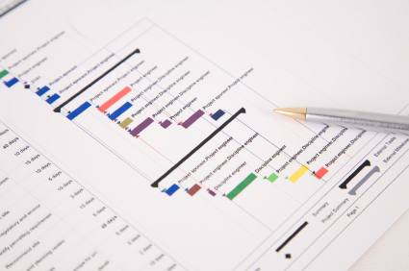

Document Control

Document Information

 | Information
Document Id | [Document Management System #]
Document Owner | [Owner Name]
Issue Date | [Date]
Last Saved Date | [Date]
File Name | [Name]

Document History

Version | Issue Date | Changes
[1.0] | [Date] | [Section, Page(s) and Text Revised]

Document Approvals

Role | Name© | Signature | Date
Project Sponsor
Project Review Group
Project Manager©
Quality Manager
(if applicable)
Procurement Manager
(if applicable)
Communications Manager
(if applicable)
Project Office Manager
(if applicable)

Table of Contents
<Project Name> i
<Project Reference> i
SCHEDULE MANAGEMENT PLAN i
Version <1.0> i
<dd/mm/yyyy> i
Document Control i
Document Information i
Document History i
Document Approvals i
Template Guide 1
SCHEDULE METHOD AND TECHNIQUE 2
SCHEDULING SOFTWARE 2
ESTIMATE TOLERANCES 2
Scheduling measurements 2
related organisational procedures 3
SCHEDULE MAINTENANCE 3
SCHEDULE TOLERANCES 3
MEASURING PROGRESS 3
SCHEDULING AND REPORTING FORMAT 3
DOWNLOAD MORE PROJECT TEMPLATES 5

Template Guide
How to use this template
This is a guide to the common sections included in a Schedule Management Plan. Sections may be added, removed or amended to suit your project. Example tables have been added (where relevant) these are just a suggestion, you may decide to format these sections differently.
Text in Blue italics is designed to assist you in completing the template. Delete this text before sharing the final document.

SCHEDULE METHOD AND TECHNIQUE
<Document the schedule method and techniques that will be used. This may already be decided by your organizations Project Management Method. For example, critical path method and rolling wave planning.>

SCHEDULING SOFTWARE
<Note the scheduling software that will be used during the project. This may well be already decided by a wider organizational standard. You could include any requirements around additional licenses and refer to any default settings that will be used. For example, pre-agreed non-working days so that work is not scheduled over holidays like Christmas.>

ESTIMATE TOLERANCES
<Document the procedure that you will use when the project or a work package is forecast to exceed the schedule or cost tolerances.
See an example of cost tolerances.>

Scheduling measurements
<Note the unit of measurement which will be used for each resource type on your project. For example, staff hours or days, for time durations or meters, tons, kilometers for quantity measures.
You could use a table like the one shown below.>
Item | Unit of measurement
Human resources effort | Days and Hours. Min 4 hours and max 10 days. Greater duration requires further decomposition to ensure scheduling accuracy.
Human resources cost | Day rate x effort. Minimum ½ day.
Concrete | Cubic meters + 0% reserve
Sand | As for Concrete
Container | Number of items at x m2.

Get a Resource Plan template.

related organisational procedures
<Include relevant links to organizational procedures. For example, process documentation for the control and updating of the schedule, or pre-agreed settings in the scheduling tool like nonworking time or the duration of the working day.>

SCHEDULE MAINTENANCE
<Explain how the schedule will be maintained. For example, how it will be updated (perhaps via project team calls), version numbering and control, and who will own the master plan. Also describe how the progress of tasks in the schedule will be shown. For example, when and how schedule baselines will be created.>

SCHEDULE TOLERANCES
<Document the amount of deviation from agreed schedule tolerances that can happen before corrective action needs to be taken.
Sometimes known as variance thresholds, schedule tolerances are percentage deviations from the schedule’s baseline. For example, it might be permissible for scheduled activities to be delayed by up to 5% but no further. Another example could be that it is acceptable to be behind schedule by up to one week, but any further delay would trigger a project board escalation.>
What is Project Tolerance?

MEASURING PROGRESS
<Document the procedure for saving the baseline (the dates against which progress will be measured). Note how and when actual start and finish dates will be collected, and for tasks in progress how the amount of work completed, and the time needed to finish the task is measured.
Include what tools or techniques will be used to establish the progress of the work against the schedule overall. For example, earned value management techniques, schedule variance, and schedule performance index.>

SCHEDULING AND REPORTING FORMAT
<Make a note of the formats that you plan to use to for scheduling and reporting. For example, you might use a Gantt Chart and Tracking Gantt for day to day management of the project combined with resource to do lists. For reporting purposes, you might use a timeline format. This could be created separately in PowerPoint of use Microsoft Project’s inbuilt timeline function.>
Example formats
Timeline created with Microsoft Project
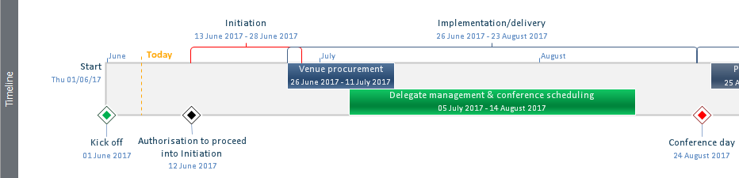
Timeline built in PowerPoint
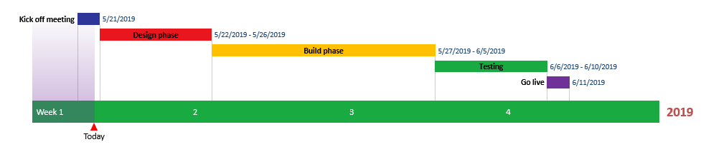
See also:
How to make a timeline in PowerPoint
How to use Microsoft project to create a timeline

DOWNLOAD MORE PROJECT TEMPLATES
Microsoft Project Plans – real world project plans in Microsoft Project.
Project Management Templates – FREE project management templates in Word and Excel
Stakeholder Management Templates
Flowcharts to download in Visio and PDF
Risk Register in Excel – download immediately
Work Breakdown Structure Excel template
Work Breakdown Structure (WBS) FREE examples to download immediately.

