[](http://www.stakeholdermap.com/project-templates/project-management-templates.html)

*<COMPANY OR PROJECT LOGO>*

## <Project Name>

## <Project Reference>

# SCHEDULE MANAGEMENT PLAN

### Version <1.0>

### <dd/mm/yyyy>

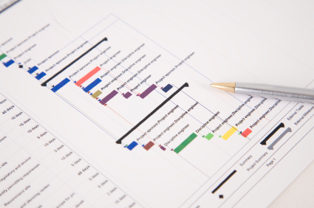

# Document Control

## Document Information

|  |  |
| --- | --- |
|  | **Information** |
| Document Id | *[Document Management System #]* |
| Document Owner | *[Owner Name]* |
| Issue Date | *[Date]* |
| Last Saved Date | *[Date]* |
| File Name | *[Name]* |

## Document History

|  |  |  |
| --- | --- | --- |
| **Version** | **Issue Date** | **Changes** |
| *[1.0]* | *[Date]* | *[Section, Page(s) and Text Revised]* |
|  |  |  |
|  |  |  |

## Document Approvals

|  |  |  |  |
| --- | --- | --- | --- |
| **Role** | **Name©** | **Signature** | **Date** |
| Project Sponsor |  |  |  |
| Project Review Group |  |  |  |
| Project Manager© |  |  |  |
| Quality Manager  *(if applicable)* |  |  |  |
| Procurement Manager  *(if applicable)* |  |  |  |
| Communications Manager  *(if applicable)* |  |  |  |
| Project Office Manager  *(if applicable)* |  |  |  |

**Table of Contents**

<Project Name> i

<Project Reference> i

SCHEDULE MANAGEMENT PLAN i

Version <1.0> i

<dd/mm/yyyy> i

Document Control i

Document Information i

Document History i

Document Approvals i

Template Guide 1

SCHEDULE METHOD AND TECHNIQUE 2

SCHEDULING SOFTWARE 2

ESTIMATE TOLERANCES 2

Scheduling measurements 2

related organisational procedures 3

SCHEDULE MAINTENANCE 3

SCHEDULE TOLERANCES 3

MEASURING PROGRESS 3

SCHEDULING AND REPORTING FORMAT 3

DOWNLOAD MORE PROJECT TEMPLATES 5

# Template Guide

***How to use this template***

*This is a guide to the common sections included in a Schedule Management Plan. Sections may be added, removed or amended to suit your project. Example tables have been added (where relevant**) these are just a suggestion, you may decide to format these sections differently.*

*Text in Blue italics is designed to assist you in completing the template. Delete this text before sharing the final document.*

# SCHEDULE METHOD AND TECHNIQUE

*<Document the schedule method and techniques that will be used. This may already be decided by your organizations Project Management Method. For example,* [*critical path method*](https://www.stakeholdermap.com/ms-project/Critical-Path-analysis.html) *and rolling wave planning.>*

# SCHEDULING SOFTWARE

*<Note the* [*scheduling*](https://www.stakeholdermap.com/project-dictionary/project-dictionary-p.html#project-schedule) *software that will be used during the project. This may well be already decided by a wider organizational standard. You could include any* [*requirements*](https://www.stakeholdermap.com/project-dictionary/project-dictionary-r.html#requirement) *around additional licenses and refer to any default settings that will be used. For example, pre-agreed* [*non-working days*](https://www.stakeholdermap.com/ms-project/microsoft-project-add-holidays.html) *so that work is* [*not scheduled over holidays like Christmas*](https://www.stakeholdermap.com/ms-project/Holidays-MSProject-Calendar.html#ever-forgotten-to-include-holidays-in-your-ms-project-plan)*.>*

# ESTIMATE TOLERANCES

*<Document the procedure that you will use when the project or a* [*work package*](https://www.stakeholdermap.com/project-dictionary/project-dictionary-w-z.html#work-package) *is forecast to exceed the* [*schedule or cost tolerances*](https://www.stakeholdermap.com/project-management/project-tolerance.html)*.*

*See an example of* [*cost tolerances*](https://www.stakeholdermap.com/project-management/project-tolerance.html)*.>*

# Scheduling measurements

*<Note the unit of measurement which will be used for each* [*resource*](https://www.stakeholdermap.com/project-dictionary/project-dictionary-r.html#resource) *type on your project. For example, staff hours or days, for time durations or meters, tons, kilometers for quantity measures.*

*You could use a table like the one shown below.>*

|  |  |
| --- | --- |
| **Item** | **Unit of measurement** |
| *Human resources effort* | *Days and Hours. Min 4 hours and max 10 days. Greater duration requires further decomposition to ensure scheduling accuracy.* |
| *Human resources cost* | *Day rate x effort. Minimum ½ day.* |
| *Concrete* | *Cubic meters + 0% reserve* |
| *Sand* | *As for Concrete* |
| *Container* | *Number of items at x m2.* |

*[Get a Resource Plan template.](https://www.stakeholdermap.com/project-templates/resource-planning-template.html" \l "template)*

# related organisational procedures

*<Include relevant links to organizational procedures. For example, process documentation for the control and updating of the* [*schedule*](https://www.stakeholdermap.com/project-dictionary/project-dictionary-p.html#project-schedule)*, or pre-agreed settings in the scheduling tool like* [*nonworking time*](https://www.stakeholdermap.com/ms-project/microsoft-project-add-holidays.html) *or the duration of the working day.>*

# SCHEDULE MAINTENANCE

*<Explain how the* [*schedule*](https://www.stakeholdermap.com/project-dictionary/project-dictionary-p.html#project-schedule) *will be maintained. For example, how it will be updated (perhaps via project team calls), version numbering and control, and who will own the master plan. Also describe how the progress of tasks in the* [*schedule*](https://www.stakeholdermap.com/project-dictionary/project-dictionary-p.html#project-schedule) *will be shown. For example, when and how schedule baselines will be created.>*

# SCHEDULE TOLERANCES

*<Document the amount of deviation from agreed schedule* [*tolerances*](https://www.stakeholdermap.com/project-dictionary/project-dictionary-t.html#tolerance) *that can happen before corrective action needs to be taken.*

*Sometimes known as variance thresholds,* [*schedule*](https://www.stakeholdermap.com/project-dictionary/project-dictionary-p.html#project-schedule) *tolerances are percentage deviations from the schedule’s* [*baseline*](https://www.stakeholdermap.com/project-dictionary/project-dictionary-b.html#baseline)*. For example, it might be permissible for scheduled activities to be delayed by up to 5% but no further. Another example could be that it is acceptable to be behind* [*schedule*](https://www.stakeholdermap.com/project-dictionary/project-dictionary-p.html#project-schedule) *by up to one week, but any further delay would trigger a* [*project board*](https://www.stakeholdermap.com/project-dictionary/project-dictionary-p.html#project-board) *escalation.>*

[What is Project Tolerance?](https://www.stakeholdermap.com/project-management/project-tolerance.html)

# MEASURING PROGRESS

*<Document the procedure for saving the* [*baseline*](https://www.stakeholdermap.com/project-dictionary/project-dictionary-b.html#baseline) *(the dates against which progress will be measured). Note how and when actual start and finish dates will be collected, and for tasks in progress how the amount of work completed, and the time needed to finish the task is measured.*

*Include what tools or techniques will be used to establish the progress of the work against the* [*schedule*](https://www.stakeholdermap.com/project-dictionary/project-dictionary-p.html#project-schedule) *overall. For example,* [*earned value management*](https://www.stakeholdermap.com/project-dictionary/project-dictionary-e.html#earned-value-management-evm) *techniques,* [*schedule variance*](https://www.stakeholdermap.com/project-dictionary/project-dictionary-s.html#schedule-variance-sv)*, and* [*schedule performance index*](https://www.stakeholdermap.com/project-dictionary/project-dictionary-s.html#schedule-performance-index-spi)*.>*

# SCHEDULING AND REPORTING FORMAT

*<Make a note of the formats that you plan to use to for* [*scheduling*](https://www.stakeholdermap.com/project-dictionary/project-dictionary-p.html#project-schedule) *and reporting. For example, you might use a* [*Gantt Chart*](https://www.stakeholdermap.com/plan-project/gantt-charts.html) *and Tracking Gantt for day to day management of the project combined with* [*resource*](https://www.stakeholdermap.com/project-dictionary/project-dictionary-r.html#resource) *to do lists. For reporting purposes, you might use a timeline format. This could be created separately in PowerPoint of use* [*Microsoft Project’s*](https://www.stakeholdermap.com/project-dictionary/project-dictionary-m.html#microsoft-project) *inbuilt timeline function.>*

*Example formats*

***Timeline created with Microsoft Project***

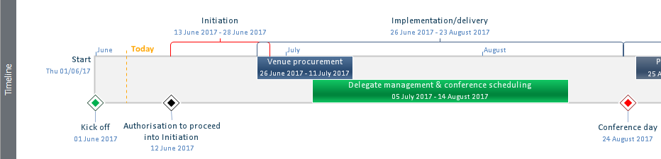

***Timeline built in PowerPoint***

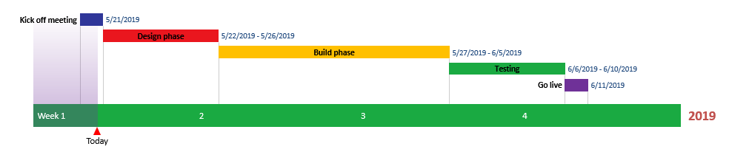

*See also:*

[*How to make a timeline in PowerPoint*](https://www.stakeholdermap.com/plan-project/timeline-maker-powerpoint.html)

[*How to use Microsoft project to create a timeline*](https://www.stakeholdermap.com/ms-project/microsoft-project-timeline.html)

## DOWNLOAD MORE PROJECT TEMPLATES

[Microsoft Project Plans](https://www.stakeholdermap.com/project-templates/ms-project-templates.html) – real world project plans in Microsoft Project.

[Project Management Templates](https://www.stakeholdermap.com/project-templates/project-management-templates.html) – FREE project management templates in Word and Excel

[Stakeholder Management Templates](https://www.stakeholdermap.com/stakeholder-management-templates.html)

[Flowcharts to download](https://www.stakeholdermap.com/business-analysis/flow-charts.html) in Visio and PDF

[Risk Register in Excel –](https://www.stakeholdermap.com/risk/risk-register.html) download immediately

[Work Breakdown Structure Excel template](https://www.stakeholdermap.com/project-templates/WBS-excel-template.html)

[Work Breakdown Structure (WBS)](https://www.stakeholdermap.com/plan-project/example-work-breakdown-structures.html) FREE examples to download immediately.