<COMPANY OR PROJECT LOGO>

<COMPANY OR Project Name>

<Reference>

RISK DATA SHEET

Version <1.0>

<dd/mm/yyyy>

Document Control

Document Information

 | Information
Document Id | [Document Management System #]
Document Owner | [Owner Name]
Issue Date | [Date]
Last Saved Date | [Date]
File Name | [Name]

Document History

Version | Issue Date | Changes
[1.0] | [Date] | [Section, Page(s) and Text Revised]

Document Approvals

Role | Name© | Signature | Date
Project Sponsor
Risk Manager
PMO
(if applicable)
Supplier Project Manager
(if applicable)
Subject Manager Specialist
(if applicable)

Table of Contents
<COMPANY OR Project Name> i
<Reference> i
RISK DATA SHEET i
Version <1.0> i
<dd/mm/yyyy> i
Document Control 1
Document Information 1
Document History 1
Document Approvals 1
Template Guide 4
Executive SUmmary 5
Risk Data Sheet 6
Download more Risk Management Templates 1

Template Guide
How to use this template
This is a guide to the common sections included in a Risk Data Sheet. Sections may be added, removed, or amended to suit your business or project. The example tables are just a suggestion; you can decide to format these sections differently.
Text in Blue italics is designed to help you complete the template. Before sharing your plan, delete this section and the help text in italics between <…>
Styles used for the Section Headings are Heading 1, Heading 2 and Heading 3. Style used for boilerplate text is Normal Text, font Arial, size 10.
To update the Table of Contents, right-click on it and select "Update field" and choose the option - "Update entire table".

Executive SUmmary
<A Risk Data Sheet provides additional data for specific risks that can’t be managed simply using the Risk Register.
Explain why this risk requires a data sheet and how the data sheet will be used to manage the risk in particular the progress of the risk responses.
For example:
‘Risk 254 relates to the production and delivery of the glass sliding windows, which are being custom made by a specialist supplier in Germany. The primary risk is that the customizations will be more complicated than expected and cause a delay in delivery of the windows. This will then have knock on impact on the whole project. There are several responses that can be considered each with different impacts. There is also the possibility of accepting the risk which will require a contingency plan. Because of these complications this risk will be tracked via a data sheet, monitored by the project board via their monthly meetings and response options will be investigated as a separate work stream/work package led by the architect and construction manager.’
Learn more about the Risk Data Sheet.>

Risk Data Sheet
Risk ID |  | Risk Description |  |  |  |  | Status
<The unique ID for the risk> |  | <Describe what the risk is. It helps to use this format ‘if x happens then it will cause y.’> |  |  |  |  | <e.g. Open, WIP, closed>
Probability |  | Impact <what will the impact be if the risk occurs?> |  |  |  |  | Score
 |  | Scope | Quality | Schedule |  | Cost
<what is the likelihood of the risk occurring?> |  | <1 – 10, High, Med, Low, or other scale> | <1 – 10, High, Med, Low, or other scale> | <1 – 10, High, Med, Low, or other scale> |  | <1 – 10, High, Med, Low, or other scale> | <Total of numeric scores multiplied or a combination of high, med, low>
Responses (mitigating actions) |  |  |  |  |  |  | Owner
<Describe how you will reduce the probability and/or impact of the risk occurring.> |  |  |  |  |  |  | <The owner of the actions.>
Revised Probability |  | Revised Impact |  |  |  |  | Revised Score
 |  | Scope | Quality | Schedule |  | Cost
Secondary Risks
<Sometimes what you do to mitigate a risk causes another. For example, making a change to a supply route might increase the risk of delay.>
Residual Risks
<Residual risk is the risk that remains after mitigating actions have been taken.>
Contingency Plan
<Explain what you will do if the risk does occur. Contingency Plans are developed for risks that have been accepted.>
Contingency Time | <The time that will be needed to implement the contingency plan.> |  |  |  | Contingency Funds | <The funds that are set aside to implement the contingency plan.>
Fallback Plan
<Describe what you will do if the contingency plan does not work out.>

Risk Assessment Matrix
<Include a copy of your Risk Assessment Matrix to illustrate how the risk score drives the actions that should be taken to manage the risk.>

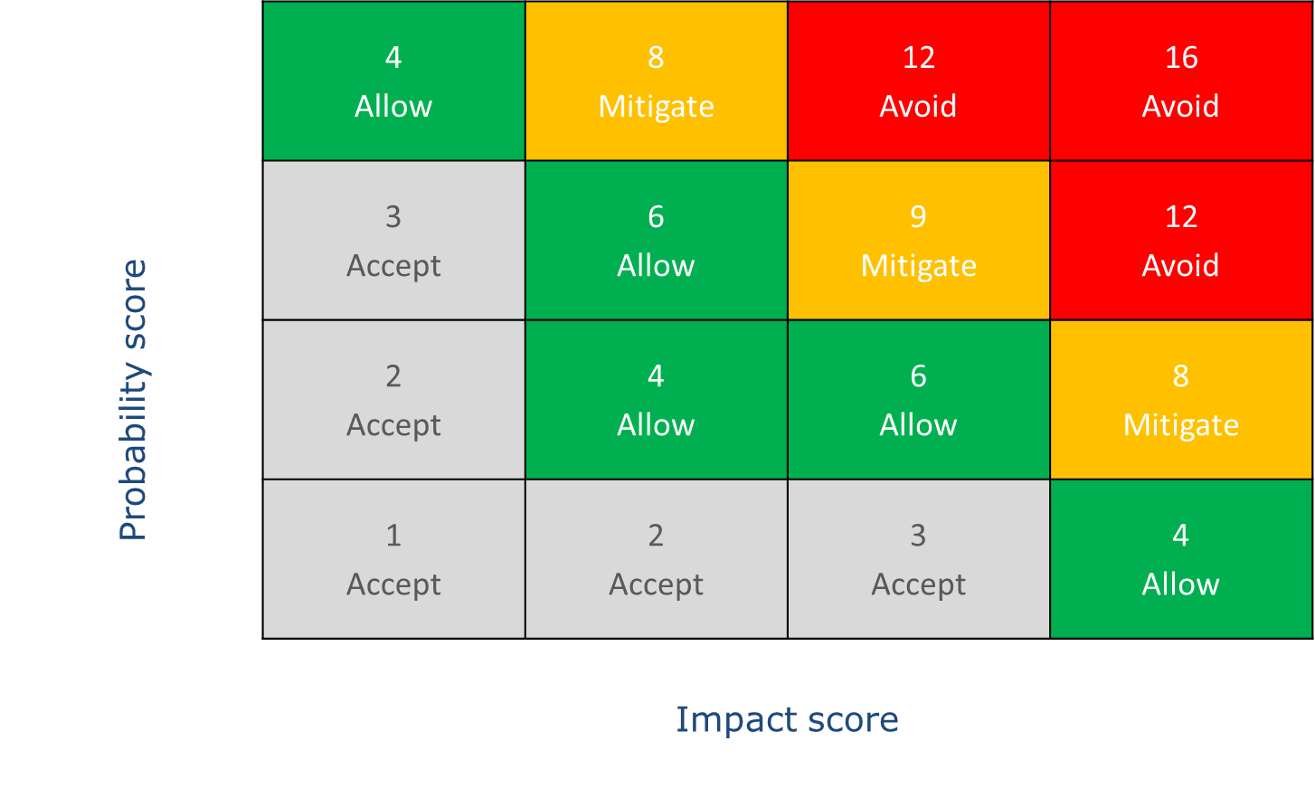

Download more Risk Management Templates
Business Templates – All of our FREE templates for Business and Management. Including timesheets, HR templates, marketing and SWOT.
Project Management Templates – Our collection of FREE Project Management templates in Word and Excel.
Risk Management Templates – Get real world Risk Registers, management plans and matrices.

