YOUR COMPANY  Project / programme name | Plan better  Engage stakeholders  Deliver success
Virtual stakeholder
engagement
Planning template
Plan useful online activities, support participation
and follow through on questions and concerns

 Set a clear purpose   Understand your  stakeholders   Prepare the session  and support access   Answer questions  and follow through | 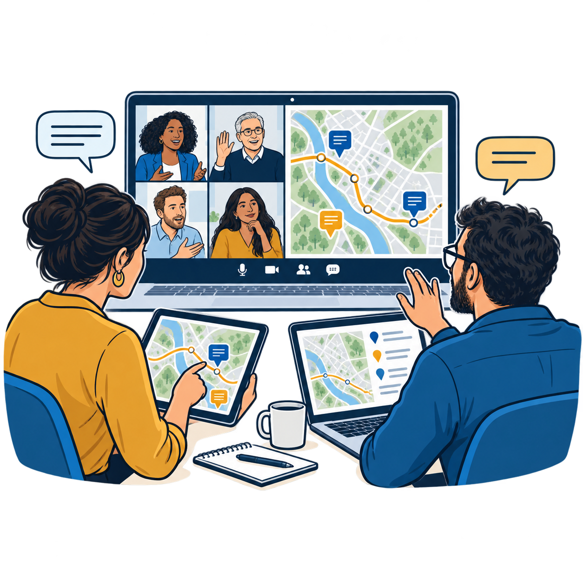
Plan owner [Name and role] Version and date [Version / date]

Using this plan
Complete sections 1 to 4 before the event and set the targets in section 6. Use section 5 to track questions and actions, then complete section 6 after the activity.
Replace the prompts in square brackets. Add rows as needed. Copy sections 3 and 4 for each activity and keep one shared follow-up log. Section 7 is a fictional worked example, not an HS2 event.

SET THE PURPOSE

1 Set the purpose
Start with what participants need. An event can explain agreed work, answer questions or help shape a decision. Be clear about which of these you are offering.
Project [Project name]
Engagement period [Start and end dates]
Who is this for
[Name the main audience and how the project affects them]
Why would they attend
[The question, concern or opportunity that matters to this audience]
What should participants get from it
[What they should understand, be able to do or receive afterwards]
What does the project team need to learn
[Questions, concerns, local knowledge or views you need to hear]

Explain what people can influence
Purpose and limits
[Are you explaining agreed work, discussing options, or both? What is fixed and why?]
Open to change
[What can people influence? Write “information and questions only” if appropriate]
Decision owner and date [Who decides / when / not applicable if no decision is involved]
Promise to participants
[What will you send afterwards, through which routes, and by what date?]

Before invitations go out
Check that the purpose, limits and response promise are clear; affected groups have a route to take part; and staff and access support are available.
Checked by and date [Name / date / unresolved action and owner]
ENGAGE STAKEHOLDERS

2 Reach people and remove barriers
Identify directly affected people as well as the wider interested audience. Ask about access needs early enough to arrange support.
Audience and reason to take part | Invitation route | Barrier and practical support
[Group / effect or interest] | [Contact or channel / sender / send date] | [Barrier / support / owner / due date]
[Group / effect or interest] | [Contact or channel / sender / send date] | [Barrier / support / owner / due date]
[Group / effect or interest] | [Contact or channel / sender / send date] | [Barrier / support / owner / due date]

Consider timing, caring responsibilities, language, disability, devices, internet access and confidence using the platform.
Who might still be missing
[Which affected groups need direct contact? Who will contact them, and by when?]

Provide more than one way to contribute
Alternative to joining online
[Give the telephone number, postal address or appointment route; name who monitors it]
Access arrangements
[Captions, accessible documents, language support, maps explained aloud or other support; owner and due date]
Help contact [Name / telephone or email / availability]
One route into the follow-up log
[Who records phone, paper and online contributions in section 5, and how often?]
How people receive answers
[Online and offline response routes; do not assume everyone can use a recording]
PLAN THE ACTIVITY

3 Prepare the activity
Choose a format that suits the audience and purpose. Complete this page for each activity.
Activity reference and title [Reference / a title that tells people why to attend]
Audience and intended result [Who it is for / what it should achieve]
Choose a format | Use it when you need to
Public webinar with questions | Explain work and answer common questions.
Small online workshop | Discuss options and work through concerns.
Private video or phone appointment | Address an individual or sensitive issue.
Online exhibition with a response route | Let people review information and comment at a convenient time.

Chosen format and reason [Format / why it fits this audience]
Date and joining details [Date / start and end / time zone / platform / link or registration route]
Response window [Opening and closing dates for questions or comments, if applicable]

Prepare the invitation
Include the purpose and limits, date and time zone, duration, joining instructions, ways to ask questions, help contact, access support and recording arrangements.
Invitation owner and send date [Name / date / direct invitations and publicity routes]
Materials and send date [Accessible slides, route description or other information / owner / date]
Recording and information [Yes or no / purpose / audience / notice to participants / access and deletion arrangements]

Name the delivery team
Role | Responsibility | Named person
Host | Introduce, keep time and invite questions. | [Name]
Subject expert | Explain the topic and answer questions. | [Name / topic]
Technical support | Manage joining, sound and screen sharing. | [Name]
Question coordinator | Group questions and log unanswered items. | [Name]

Staff time and costs [Hours / platform and access costs / budget owner]
PREPARE AND DELIVER

4 Run the activity
For a webinar, the article suggests protecting half the available time for questions. Adapt the example below. For a workshop, allow discussion throughout; for an exhibition, list opening, monitoring and closing tasks instead.
Activity reference [Match section 3]
Minutes | Activity | Lead
0 to 5 | Welcome, purpose, limits and how to ask questions. | [Host]
5 to 25 | Explain the work, options or topic. | [Expert]
25 to 55 | Questions and discussion with the panel. | [Host / experts]
55 to 60 | Next steps, contacts and date for outstanding answers. | [Host]

Prepare for questions and problems
Likely difficult questions [Key concerns / expert preparing answers / checks still needed]
Question process [Advance questions / live queue / grouping repeats / fair coverage of criticism]
Private concerns [Separate contact route for personal or sensitive matters]
Unanswered questions [Who logs them / how a response date will be agreed and announced]
Backup plan [Backup host / loss of connection or video / how participants are told]
If prepared questions start the discussion, identify them as common questions. Explain moderation rules and give relevant criticism a fair hearing.

Rehearse and check readiness
Rehearsal date [Date / participants]
For each check, record Ready, Action needed or Not applicable. Do not mark a check Ready until the action is complete.
Check | Status or action | Owner and due date
Participant joining, sound and screen sharing tested | [Status / action] | [Name / date]
Accessible materials and support checked | [Status / action] | [Name / date]
Speaker handovers, timings and backup rehearsed | [Status / action] | [Name / date]
Question log, follow-up and closing message ready | [Status / action] | [Name / date]

Final check [Lead / date / go ahead or changes needed]
FOLLOW THROUGH

5 Track questions and follow through
Use one log for contributions from every channel. Keep contact details separately where access can be restricted. Add rows and keep issue references consistent.
Issue and source | Question or concern | Action and owner | Due date and status
[Ref / date / channel / group] | [What was raised] | [Next step / named owner] | [Date / open, in progress or closed]
[Ref / date / channel / group] | [What was raised] | [Next step / named owner] | [Date / status]
[Ref / date / channel / group] | [What was raised] | [Next step / named owner] | [Date / status]

Record the answer or outcome
Complete a record below for each issue that needs follow-up. Copy these fields as needed. For a straightforward question, the answer may be the outcome; no project change is required.
Issue reference [Match the log above]
Answer or decision and reason
[What did you establish? What changed, or why could a suggestion not be accepted?]
Evidence and different views
[Checks or advice used; record disagreement or unresolved concerns]
Response sent [Date / channel / recipient or public summary reference]
Closure or next update [Resolved and response sent / remaining action, owner and update date]

Send the promised follow-up
Deliverable | Owner | Due date and completion
Materials and answers promised at the event | [Name] | [Due / sent / reference]
Summary of views and changes, if relevant | [Name] | [Due / sent / reference]
Answers for people using offline routes | [Name] | [Due / sent / reference]

Overdue items [References / who will chase them / next review date]
Remove personal details from public answers. Close an item only when the response and any agreed action are complete; otherwise record the next update.
MEASURE RESULTS

6 Check whether it helped
Set your targets before inviting people. Complete the results after the activity and review outstanding actions on the dates promised.
Activity and review [Activity reference / reviewer / review date]
Question | Target and evidence before the activity | Result and next action afterwards
Who took part? | [Groups to reach / how you will check] | [Groups represented / missing / contact needed]
Could people contribute? | [How you will identify joining or access problems] | [Barriers reported / support or change needed]
Did people get what they needed? | [How you will ask about useful answers and clear next steps] | [Feedback / gaps / further explanation needed]
What happened afterwards? | [Response dates / how actions will be checked] | [Answers and actions completed / overdue / owner]

Keep the counts separate
Registrations [Number / period / source]
Live attendance [Number / how repeat joins were handled]
Recording views [Views / platform definition / measurement date; not unique participants]
Outstanding items [Total due / completed / overdue as at the review date]
Review directly affected groups separately from the wider interested audience. High attendance does not show that an access problem or other concern has been resolved.

Ask participants
Were the information and answers useful? Could you contribute in the way you needed? Are the next steps clear? What should we improve? Offer a short online and offline response route.
Feedback collection
[Who asks / how / by when / where responses are recorded]
Keep or change next time
[What worked / specific change / owner / due date]
Next review [Date / owner / outstanding items to check]
WORKED EXAMPLE

7 Worked example
Fictional example showing how the fields connect. The dates, targets and results below are illustrative and are not findings from HS2.

Road diversion briefing
A bridge replacement requires a road closure. Residents need to understand the route; nearby shops need workable delivery access. The closure is fixed, but delivery windows can still change.
Planning field | Completed example
Purpose and audience | Explain the diversion to residents and businesses; hear delivery and access concerns. Aim to hear from all five shops directly affected.
Activity and timing | Online briefing on 10 November, 18:00 to 19:00 UK time. Use the 5 / 20 / 30 / 5 minute agenda. Accept phone and written questions until 12 November.
Invitation and access | Engagement lead sends invitations on 27 October and calls all five shops. Send accessible route information on 6 November. Arrange captions and offer phone appointments and posted material.
Delivery and rehearsal | Engagement lead hosts; engineer answers route questions; administrator runs the platform; community liaison officer logs questions. Rehearse on 9 November, including a failed speaker connection.
Response promise | Send materials and a summary of answers by 19 November. Confirm a separate update date for any issue that remains open.

One concern from question to closure
Q01, received by phone on 10 November: a shop cannot receive stock after 09:00. The question coordinator adds it to the shared log. The logistics lead checks a supervised 07:00 to 08:00 delivery window by 16 November.
The project manager approves the revised window on 17 November. The engagement lead calls the shop and posts confirmation on 18 November. Q01 closes after the delivery plan is updated and the response is sent.

Review and next action
Four of five shops contributed, so the reach target was not met. The community liaison officer contacts the fifth shop by 20 November. There were 32 registrations, 24 live attendees and 11 recording views by 19 November; these counts are kept separate.

Article and source
Virtual stakeholder engagement practical lessons from HS2
HS2 Learning Legacy case study by Jane Smith and Allan Fatah 2022
This template applies the article’s lessons. It is not an HS2 form and does not imply HS2 endorsement.

